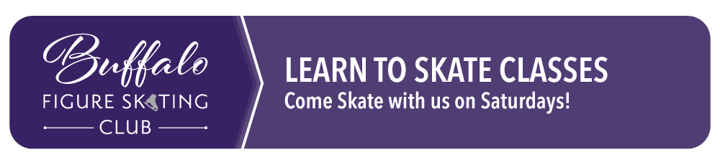
We are dedicated to using Ice Skating Institute (ISI) standards for advancement of skating skills used for figure skating. Our goal is to provide a productive and fun atmosphere for students age 3 and older, of varying abilities, to advance their skills!

- All group classes are 30 minutes.
- Helmets are strongly encouraged for all skaters and are required for Tot and Pre-Alpha classes.
- Class size is limited to 5 - 12 skaters depending on level. In the event of low enrollment some classes may be canceled or consolidated with another level or time slot.
- It is common for skaters to stay at their skating level for more than 1 session.
- We offer ISI sanctioned, hockey-specific skating instruction for tots through Mite and U8 levels. No sticks allowed, we focus on skating skills.
- No parents or older siblings allowed on the ice
- No refunds.
Saturday Classes: 9/19, 9/26, 10/3, 10/10, 10/17, 10/31, 11/7, 11/14
Time Options: 9:30 - 10:00 am

Available Classes
- Beginner Tots: Skaters ages 3-4. Skaters will learn basic skills to be comfortable on the ice - they will learn to stand up, march, and eventually gliding. Figure skating and hockey tots work on the same skills and will be combined.
NOTE: Beginner Tot class is only 20 minutes.
- Tots Advanced: Skaters ages 4-5 who have skated before and are able to stand independently on the ice. They must be able to stand and march without assistance - they will learn two-foot hops, and eventually gliding. Figure skating and hockey tots work on the same skills and will be combined.
- Pre-Alpha: Skaters ages 5+ who have never taken classes should start here. Skaters in this class must be able to stand and march without assistance. Beginner students learn to balance and do simple glides on both feet. Figure skating and hockey skaters must pass the Pre-Alpha level before registering for a higher level.
- Pre-Alpha Mastery: Skaters ages 5+ who have been in Pre-Alpha before and are able to glide and wiggle backwards. Figure skating and hockey skaters must pass the Pre-Alpha level before registering for a higher level.
- Alpha: Must have passed Pre-Alpha
- Beta: Must have passed Alpha
- Gamma & Delta Skaters have graduated to JR CLUB on Saturday mornings & Sunday evenings!

Registration Fee: $120 for Beginner Tots Only and $140 for all other classes!
Family discount available - full price for 1st registration and 50% off all additional family registrations
Register online: BUFFALOFIGURESKATING.COM
Registration deadline is September 10, 2026. If you have questions about the program or skating levels please contact us at buffalofigureskating@gmail.com or Megan at 763-238-0965. Follow us on Facebook for the latest information: facebook.com/buffalofigureskating. This activity is NOT sponsored by the school district. This flyer is NOT printed at school district expense.
Classes will be held at Buffalo Civic Center - 1306 County Rd 134 NE, Buffalo MN.

